Requirement: Create an Asp.Net Core Web Application that receives username and password via POST request (from Postman).
It receives "email" and "password" as query string from request body.

Parameters:
email: any email address
password: any password string
Finally, it should return message as either "Successful login" or "Invalid login".

Process:
If email is "admin@example.com" and password is "admin1234", it is treated as a valid login; otherwise invalid login.

Example #1:
If you receive a HTTP POST request at path "/", if the valid email and password are submitted, it should return HTTP 200 response.
Request Url: /
Request Method: POST
Request body (input): email=admin@example.com&password=admin1234
Response Status Code: 200
Response body (output):
Successful login

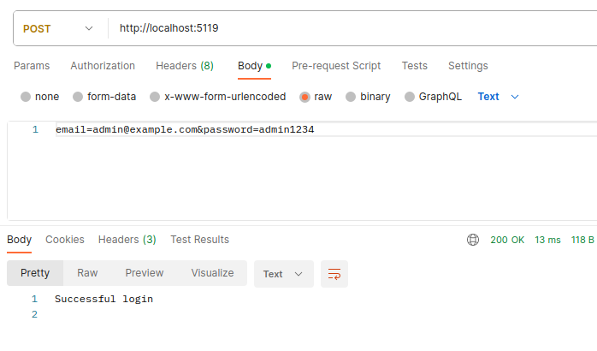

Example #2:
If you receive a HTTP POST request at path "/", if either email or password is incorrect, it should return HTTP 400 response.
Request Url: /
Request Method: POST
Request body (input): email=manager@example.com&password=manager-password
Response Status Code: 400
Response body (output):
Invalid login

Example #3:
If you receive a HTTP POST request at path "/", if neither email and password is submitted, it should return HTTP 400 response.
Request Url: /
Request Method: POST
Request body (input): [empty]
Response Status Code: 400
Response body (output):
Invalid input for 'email'Invalid input for 'password'
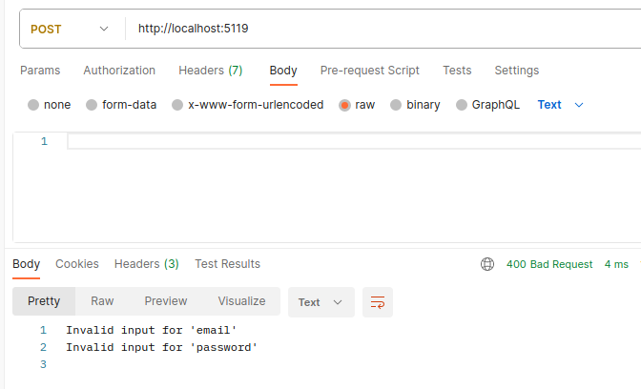
Example #4:
If you receive a HTTP POST request at path "/", if password is not submitted, it should return HTTP 400 response.
Request Url: /
Request Method: POST
Request body (input): email=test@example.com
Response Status Code: 400
Response body (output):
Invalid input for 'password'

Example #5:
If you receive a HTTP POST request at path "/", if email not is submitted, it should return HTTP 400 response.
Request Url: /
Request Method: POST
Request body (input): password=1234
Response Status Code: 400
Response body (output):
Invalid input for 'password'

Example #6:
If you receive a HTTP GET request at path "/", it should return HTTP 200 response.
Request Url: /
Request Method: GET
Response Status Code: 200
Response body (output):
No response

Instructions:
- Use custom conventional middleware (with middleware extensions) to handle the post request at path "/"
- The "email" and "password" values are mandatory
- Return appropriate HTTP status codes based on above examples.

